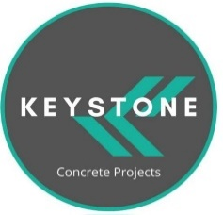 | Company PROFILE
 | KEYSTONE CONCRETE PROJECTS

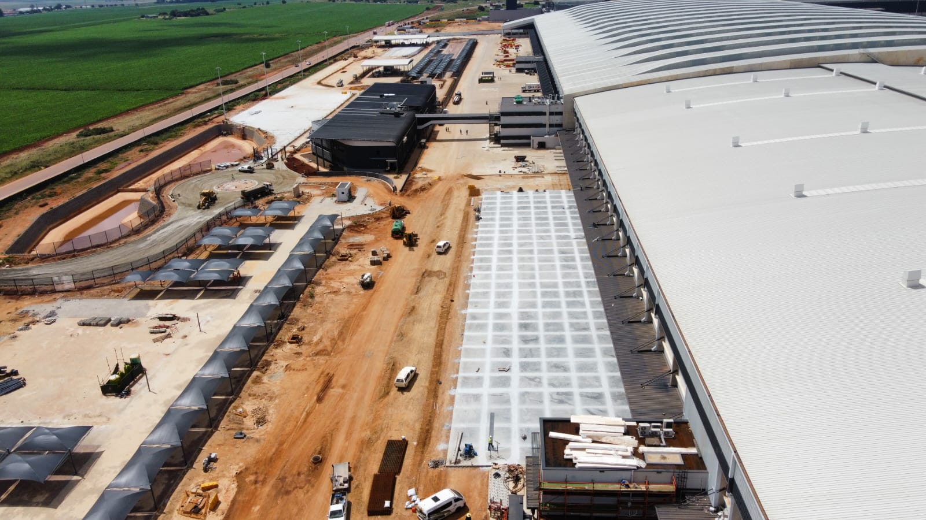

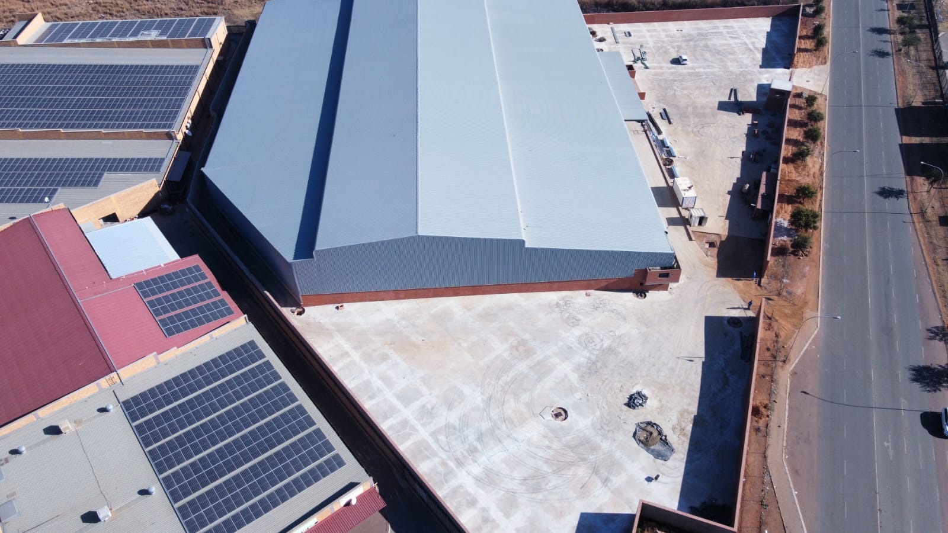
Tel No: +27 67 329 0235 / +27 81 598 0846 / +27 69 096 4270
Email: info@keystoneza.co.za / dirk@keystoneza.co.za
  - 1. BUSINESS, ADMINISTRATIVE AND CONTACT INFORMATION

  - a. Registered and trading business name:
Keystone Civils Flooring

  - b. Business type:
  - Private Company

  - c. Company registration number:
2023/626498/07

  - d. VAT number:
4190317018

  - e. COID registration number:
- 9457004225
  - f. Tel:
- +27 67 329 0235 / +27 81 598 0846 / +27 69 096 4270
  - g. E-mail:
- info@keystoneza.co.za / dirk@keystoneza.co.za

  - h. Physical address:
  - 71 a Jurgens street
  - Jatniel
  - Benoni
  - 1501

2. INTRODUCTION
The company has been undertaking new concrete placing, concrete repair and rehabilitation work since its inception. The company’s headquarters is situated in Johannesburg, South Africa.
Keystone Concrete Projects offers specialized services in the areas of earth works, concrete placing, concrete repair, joint sealing, concrete sealing, concrete crack injection, core drilling and epoxy / polyurethane coatings, including the formulation of repair strategies.

  - 3. STRATEGY

  - a. VISION STATEMENT
  - To be the leading concrete placing, concrete repair, rehabilitation and retrofitting company with the strength of a big company combined with the leanness and agility of a small company.

  - b. MISSION STATEMENT
Keystone Concrete Projects is a concrete placing, repair and rehabilitation and company dedicated to exceptional high-quality service adding value to our client’s assets by extending the service life of their structures. We intend to make enough profit to generate a fair return for our investors and to finance continued growth and development in concrete solutions. We also maintain a friendly, fair, and creative work environment, which respects and rewards diversity, new ideas, and hard work.

  - c. VALUES
  - The following core values reflect what is truly important to our company and underpin our company culture.
• Always act with honesty and integrity.
• Be trustworthy and dependable.
• Be passionate and determined to find the best repair solutions.
• Strive for excellence and be accountable for each delivered service.
• Satisfy our clients and become their first-choice service provider.
• Create win-win partnerships with our suppliers.
• Create wealth through profit and growth.
• Build a positive team with mutual respect and teamwork.
  - • Be humble.

  - d. GOALS AND OBJECTIVES

GOALS
• Establish Keystone Concrete Projects as the leading company in concrete placing, and repair service delivery on the African continent.
• Expand the business to employ 20 additional employees by 2025.
• Increase profit margins.
OBJECTIVES
• Deliver new concrete placing and repair solutions of the highest standard with tangible results for each of our clients.
• Invest in cutting edge equipment and instruments.
• Complete projects on time and within budget with a minimum turnaround time between projects.
• Develop long-term relationships with our clients and suppliers to become their first-choice service provider.
  - • Transferring skills to local communities by training local employed labour.

  - e. BUSINESS STRATEGY
Standing out from our competitors with superior service delivery, involvement of management in each project, pride in the work we deliver and value for money.

  - 4. BUSINESS CONCEPT

  - a. Technical service life is the time in service until a defined unacceptable state is reached, such as spalling of concrete, safety level below acceptable or failure of elements. Factors which contribute to structures reaching unacceptable states are the environment, durability of the concrete and the lack of quality control during the construction phase. By applying appropriate placing and repair strategies the service life of the structures can be prolonged which adds value to the owner’s asset and investment.

  - b. Functional service life is the time in service until the structure no longer fulfils the functional requirements. By applying appropriate rehabilitation and retrofitting strategies, the functionality of the structure can be revived which will reaffirm the structure as an asset for the owner.

Keystone Concrete Projects is a dedicated specialist in this field, whose primary aim is to add value and functional service life of strategic structures in the property and industrial environment.

The Keystone Concrete Projects team has 30 year work experience in concrete placing, repair, rehabilitation and retrofitting. They are familiar with specialized products and techniques required to repair deteriorating concrete structures and can offer the following services:
Concrete placing, powerfloat and saw cut
Concrete treatment and protective coatings Urethane and Epoxy
Concrete repair and rehabilitation
Specialized grouting and pressure grouting
Concrete strengthening utilizing carbon fibre systems
Specialized waterproofing
Crack repair and pressure injection
Chemical resistant coatings
Coring

In addition to the above Keystone Concrete Projects also offer a field-testing service to clients, consulting engineers, architects and quantity surveyors, which include the following:
• Depth of carbonation testing
• Schmidt hammer testing
• Ultrasonic image scanning – locating voids, honeycombing and delamination
• Core sampling
• Defect assessment, mapping and quantification
  - • Laboratory testing: (outsourced)
  - o Compressive strength testing
  - o Chloride content analysis
  - o Sulphate content analysis
  - o Cement content

